5.7 Public Policy and Economic Growth

- If subsidies for research and development on new technologies lead to an increase in the average productivity of labor, what will most likely happen to real GDP per capita and long-run aggregate supply (LRAS) for a given population size?
- Real GDP per capita will decrease, and LRAS will increase.
- Real GDP per capita will decrease, and LRAS will decrease.
- Real GDP per capita will increase, and LRAS will increase.
- Real GDP per capita will increase, and LRAS will decrease.
- Real GDP per capita will decrease, and LRAS will not change.
- Which of the following policy changes will most likely shift the long-run aggregate supply curve to the right?
- An increase in income taxes
- An increase in the money supply
- An increase in the required reserve ratio
- An increase in the government budget deficit financed by borrowing
- An increase in government spending on public education
- Which of the following is a supply-side fiscal policy that could stimulate economic growth?
- A decrease in income tax credits
- A decrease in marginal income tax rates
- A decrease in the sales taxes imposed on household goods
- An increase in the discount rate
- An increase in the money supply
- Which of the following will happen if a country’s government reduces business taxes?
- The short-run Phillips curve will shift to the right.
- The short-run aggregate supply curve will shift to the right.
- The long-run aggregate supply curve will shift to the left.
- The aggregate demand curve will shift to the left.
- The demand curve for loanable funds will shift to the left.
- Government investment in human capital is likely to shift
- the aggregate demand curve to the right in the short run and the aggregate supply curve to the right in the long run
- the aggregate demand curve to the left in the short run and the aggregate supply curve to the left in the long run
- the aggregate demand curve to the right in the short run and the long-run Phillips curve to the right
- the aggregate demand curve to the left in the long run
- the aggregate demand curve to the left in the short run and the long-run Phillips curve to the left
- Increases in government subsidies to encourage investment in research and development will affect aggregate demand (AD) and long-run aggregate supply (LRAS) in which of the following ways?
 | AD | LRAS
A | Increase | Increase
B | Increase | Decrease
C | Increase | No Change
D | Decrease | Increase
E | Decrease | No Change

- In the long run, government subsidies that promote the development of technology with widespread business applications will have which of the following effects?
- A negative supply shock and lower price level
- A negative supply shock and lower economic growth rate
- A positive supply shock and lower price level
- A positive supply shock and lower economic growth rate
- A lower aggregate demand and lower price level
- Which of the following would cause both the aggregate demand and aggregate supply curves to shift to the right?
- A decrease in corporate income taxes
- A decrease in government spending
- A decrease in natural resource prices
- A decrease in the stock market prices
- An increase in the international value of the domestic currency
- An increase in which of the following is most likely to promote economic growth?
- Consumption spending
- Investment tax credits
- The natural rate of unemployment
- The trade deficit
- Real interest rates
- A country’s infrastructure refers to its
- natural resources
- private financial institutions
- proportion of population with postsecondary education
- public capital goods such as highways
- internal, as opposed to external, debt
- Policymakers concerned about fostering long-run growth in an economy that is currently in a recession would most likely recommend which of the following combinations of monetary and fiscal policy actions?
 | Monetary Policy | Fiscal Policy
A | Sell bonds | Reduce taxes
B | Sell bonds | Raise taxes
C | No change | Raise taxes
D | Buy bonds | Reduce spending
E | Buy bonds | No change

Free Response
- Include correctly labeled diagrams, if useful or required, in explaining your answers. A correctly labeled diagram must have all axes and curves clearly labeled and must show directional changes. If the question prompts you to “Calculate,” you must show how you arrived at your final answer.
The economy of Beta is in a recession.
(a) Draw a single correctly labeled graph with both the short-run and long-run Phillips curves. Label the initial short-run equilibrium as point X.
(b) Identify a combination of fiscal and monetary policy actions that can be used to restore full employment.
(c) Draw a correctly labeled graph of the money market and show the effect of the monetary policy action identified in part (b) on the equilibrium nominal interest rate.
(d) Based on the change in the equilibrium nominal interest rate identified in part (c), what will happen to aggregate demand in the short run? Explain.
(e) On your graph in part (a), label a point Z that shows the effect of the change in aggregate demand identified in part (d).
(f) Now assume the economy is in long-run equilibrium. If the central bank pursues a policy of increasing the money supply at an annual rate of 5 percent, what will happen to inflation and real output in the long run? Explain using the quantity theory of money.
(g) Identify one supply-side fiscal policy action the government of Beta can use to promote economic growth.
Assume the economy of Ucheland is currently at full employment. The government of Ucheland reduces the tax rate on household interest earnings.
- What will happen to private savings in Ucheland?
- Draw a correctly labeled graph of the loanable funds market, and show the effect of the change in private savings identified in part (a) on the equilibrium real interest rate.
- Given the real interest rate change identified in part (b), answer the following questions.
  - What is the short-run effect on aggregate demand? Explain.
  - What is the long-run effect on potential real gross domestic product in Ucheland? Explain.

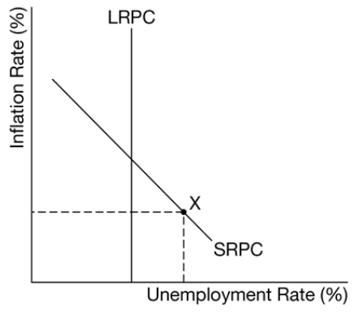
Free Response Answers
Diagram for a
B The response states an example of an expansionary fiscal policy action (i.e., an increase in government spending or a decrease in taxes) AND an example of an expansionary monetary policy action (i.e., an open market purchase of government bonds, a decrease in the required reserve ratio, or a decrease in the discount rate).
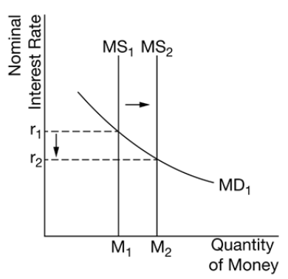
C
D The response states that aggregate demand will increase and explains that a decrease in nominal interest rates will increase interest-sensitive consumption and/or investment spending.
E 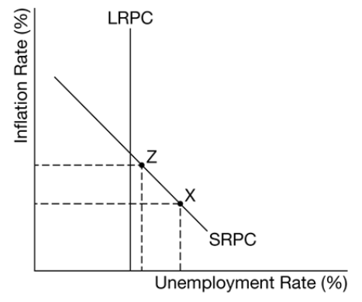
Diagram for E
F The response accurately includes both of the criteria below.
States that inflation will be 5% and real output will not change
Explains that the quantity theory of money assumes that the velocity of money and real output are not affected by changes in the money supply in the long run. Therefore, the 5% increase in the money supply will result in a 5% increase in the price level, i.e. inflation will be 5% and real output will not change.
OR
Another acceptable explanation is by directly applying the assumptions of the quantity theory of money to the equation of exchange
(%ΔM +%ΔV = %ΔP +%ΔY
5% + 0 = %ΔP + 0
Therefore, inflation, which is the percentage change in the price level, is 5%.
G The response states a supply-side fiscal policy that would promote economic growth, such as
Increasing spending on education
Increasing spending on research and development
Increasing spending on infrastructure and physical capital
Increasing spending on training to improve labor productivity
Reducing household income taxes and business income taxes
2
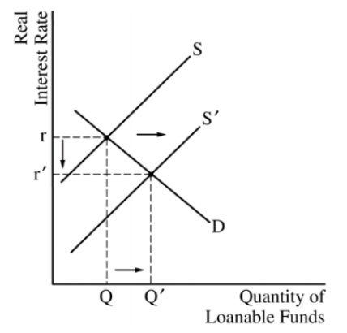
A • One point is earned for stating that private savings will increase.

Answers
1C 2E 3B 4B 5A 6A 7C 8A 9B 10D 11E
B
C One point is earned for stating that aggregate demand will increase and for explaining that the decrease in the real interest rate will result in an increase in interest-sensitive spending (consumption or investment or net exports).
• One point is earned for stating that potential real gross domestic product (GDP) will increase as a result of an increase in capital formation brought about by the increase in investment spending (or because capital formation increased the long-run aggregate supply).

